**Two Days**

**(Online)**

**International Conference**

**On**

**Reaction Engineering**

**(ICRE-2021)**

**7th - 8thMay, 2021**

**Web Site:** [**http://icre.nitrr.ac.in**](http://icre.nitrr.ac.in)

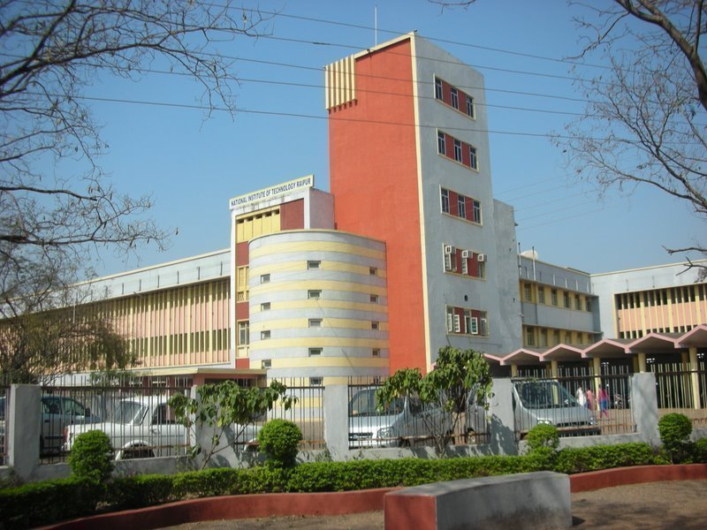

***Organized by***

**Department of Chemical Engineering**

**National Institute of Technology**

**Raipur 492010 (Chhattisgarh) India**

|  |  |
| --- | --- |
| **https://mc.manuscriptcentral.com/societyimages/dgijcre/IJCRE_cover_thumb.jpg** | **Journal Partner** |

**Journal Partner**

**Chief Patron**

**Dr. A. M. Rawani**

Director, NIT Raipur

**Patron**

Dr. (Mrs.) S. Gupta

Dean R&C, NIT Raipur

**Chairman**

Dr. A.K. Poonia, HOD, Chemical Engg.

**Secretaries**

Dr. P.K. Chaudhari

Dr. Amit Keshav

Dr. Dharm Pal

|  |  |
| --- | --- |
| **Advisory Committee Members** | |
| Dr.Ajay K. Dalai, University of Saskatchewan, Canada  Dr. Ranil Wickramasinghe, University of Arkansas, USA  Dr.Akshat Taksale, Monash University, Melbourne, Australia  Dr. Rajesh Khanna, IIT Delhi, India  Dr. K K Pant, IIT Delhi, India  Dr. [Santanu Bandyopadhyay](https://www.ese.iitb.ac.in/faculty/santanu-bandyopadhyay), IIT Bombay, India  Dr Vimal Katiyar, IIT Guwahati, India  Dr. Sishir Sinha, IIT Roorkee , India | Dr. P K Mishra, IIT BHU, India  Dr. B C Meikep, IIT Kharagpur, India  Dr. Jayant Kumar Singh, IIT Kanpur, India  Dr. Vimal Chand Srivastava, IIT Roorkee , India  Dr. Ajay Bansal, NIT Jalandhar, India  Dr. K L Wasewar, VNIT Nagpur, India  Dr. Sadhana Sachan, MNIT Allahabad, India |

.

|  |  |
| --- | --- |
| **Organizing Committee Members** | |
| Dr. (Mrs.) A. B. Soni  Dr. B. Mazumdar  Dr. V.K. Singh  Dr. R. Manivanan  Dr. P. Ghosh  Dr. J. AnandKumar | Dr. (Mrs.) S. N. Victoria  Dr. C. Thakur  Dr. A. Khapre  Dr. V. Gupta  Dr. V. Kumar |

**Address for Correspondence**

Dr. P.K. Chaudhari/Dr. Amit Keshav/Dr. Dharm Pal

*Chemical Engineering*

Email: icre2021@gmail.com

Contact No: 9630058194/9584751651

**Conference Website: icre2021.nitrr.ac.in**

**Online**

**International Conferenceon Reaction Engineering (ICRE-2021)**

**7th - 8thMay, 2021**

**REGISTRATION FORM**

Name (Mr. / Ms. / Mrs. / Dr.): …………………….

Designation : …………………..………………

Affiliation : …………………………………..

Qualification: ……………………………………..

Correspondence Address: ……………………....

Contact No. : ………………..............................

E-Mail : ……………………………..……………

Registration Fee : Cash / DD / Online TransferAmount (in fig.)…………………………..……….. (in words)................................................................................................................................

DD No. / Transaction ID.....................................Date …………………………………………………

Name of the Bank…………………..……………..

Accommodation Required: Yes / No

(Guest House / Hostel / Hotel)

Date:

Place: Signature of the Applicant

**NOTE:**

* Demand draft should be made in favor of Director, National Institute of Technology Raipur, payable at Raipur.
* Online Payment may be made to: Account No.: 38027633250 Name: Director, NIT Raipur IFSC: SBIN0002852

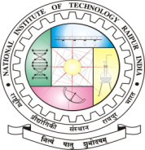

**About the Institute:**

**National Institute of Technology Raipur** situated in the capital of Chhattisgarh, has proven to be "avant-grade' in the field of science and technology over past few decades in this region. With sweet memory of foundation by our first president Hon'ble Dr. Rajendra Prasad on 14th Raipur railways station and 18 km from airport September 1956, the institute started with two departments namely Metallurgical and Mining Engineering. Later the inauguration of the Institute building was done by our first Prime Minister Hon'ble Pt. Jawahar Lal Nehru on 14th March 1963. From 1st December 2005, the institute has become the National Institute of Technology. It is well connected with Mumbai, Delhi, Kolkata, Chennai, Hyderabad and other main cities by regular flights and is on the main Howrah-Mumbai railway route. The institute is 5 km from the on NH-6, the Great Eastern Road.

**About Department:**

The Chemical Engineering Department was established in the year 1962. The Department is offering undergraduate course (B.Tech in Chemical engineering) and one post-graduate course (M.Tech in Chemical Engineering). The Department has well qualified and committed faculties. There are 15 faculty members in the Department.  Faculty members have successfully completed more than 20 research projects sponsored by various funding agencies (valuing more than 2 crore).

**Theme/Scope:**

The goal of this conference is to bring together the scientists, scholars, and students from universities, research institutes, and industry from all around the nation. This conference will provide opportunities for the attendees to exchange new ideas face to face, to establish research or business relations and to find opportunities for future collaboration.

**Topics to be covered:**

Chemistry and chemical reaction engineering   
Chemical equipment and process design  
Analytical and computational chemistry  
Catalytic, biochemical & biological reactions

Mixing & transport processes in chemical reactors

Computational modeling of chemical processes

Modeling& design of chemical reactors

Control & optimization of chemical reactors

Photosynthesis reactions

Polymerisation reactions

Thermo-chemical conversions of biomass

Clean & sustainable energy

Waste to wealth

Electrochemical reactors & processes

Advanced materials

Wastewater treatment, recycle & reuse

Novel reactors &process intensification

Coal & petroleum energy

Chemical sensors

Miscellaneous topics

**Targeted Participants*:***

* Scientists from R&D / Industry
* Faculty Members
* Research Scholars
* UG / PG Students

**Registration Fee Details (in INR):**

|  |  |
| --- | --- |
| **Participants** | **Amount** |
| Students | INR 472 including GST |
| Faculty& others | INR 944 including GST |
| International Participants | US $ 60 +18%GST |

**Paper publication/Indexing charges will be extra as applicable (if any)**

Fee is non-refundable**.** Selected candidate will be informed by email as per the schedule.

**Objective:**

This International Conference on Reaction Engineering (ICRE) 2021 is the international platform which brings together the collection of researchers who are at the forefront in the field of Reaction Engineering. The scientific program will include oral presentations of sub-disciplines, keynote sessions led by eminent scientists and poster sessions presented interactively by junior scientists and graduate students. It is the ultimate meeting place for all the experts worldwide for new inter disciplinary scientific collaborations and networking. There will be oral & poster presentation competition for UG / PG / M. Tech / Research Scholars / Faculty members related to various chemical and biological reactions.

**Abstract Selection**:

Since the numbers of seats are limited to 50, the selection will be made on first cum first basis and intimation will be sent to the candidates by email as per the deadlines. Submit abstract to [icre2021@gmail.com](mailto:icre2021@gmail.com)

M**anuscript Submission :**

**After acceptance of abstract, submit your manuscript to:**

**“ICRE –India 2021”** S**pecial issue of the** International Journal of Chemical Reactor Engineerin**g (IJCRE)**

**Important Deadlines:**

Abstract Submission : 5th April, 2021

Acceptance Notification : 10th April, 2021

Registration Deadline : 25th April, 2021

Full Length Paper Submission: 25th April, 2021

**Highlights:**

* Virtual presentation through online mode
* Best oral presentation award
* Publication in “IJCRE, special issue”, a**nd** Book Chapters

**ue,**